**ENGN2605 Lab 07**

**Instructor: Prof. Benjamin Kimia**

**Name: Kuan-Min Lee**

**Brown ID: 140481859**

**Problem 1. Image Formation:**

This section of the experiment involves in projecting a 3D view from real world coordinates onto the image planes of the two cameras at two different locations. The camera posses the same properties, which results in the fact that the two cameras posses the same intrinsic calibration matrix. The rotation matrices of the two cameras are represented as R1 and R2 respectively, and the translation matrix of the two cameras are represented as T1 and T2. The below are the images from the image planes of camera 1 and 2:

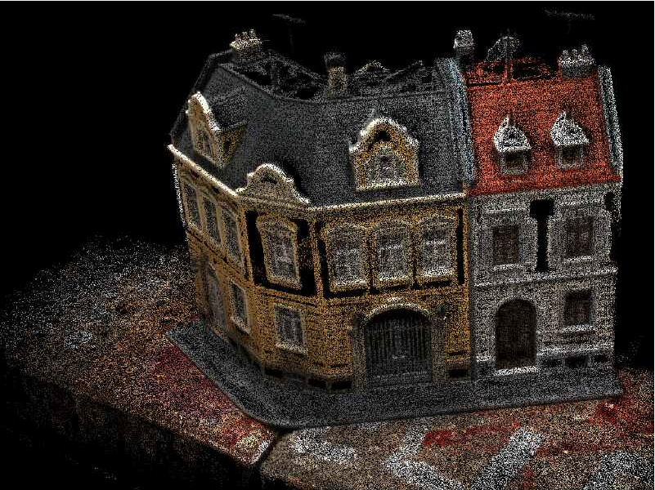

Figure 1: Outcome Image from Image Plane of Camera 1

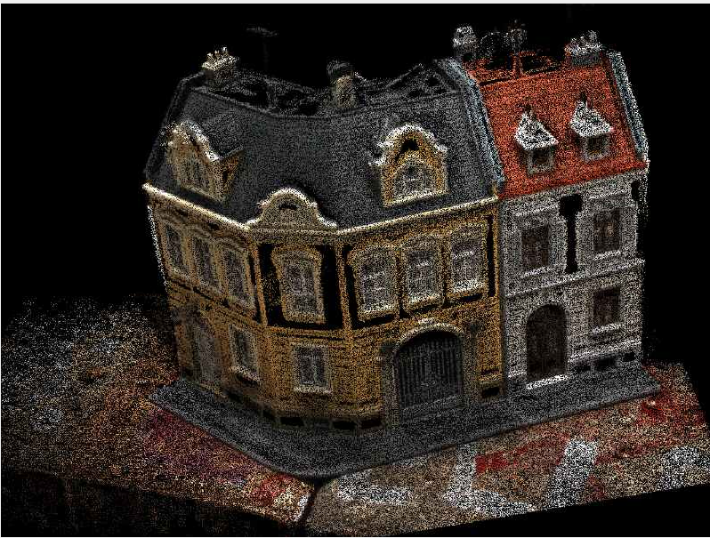

Figure 2: Outcome Image from Image Plane of Camera 2

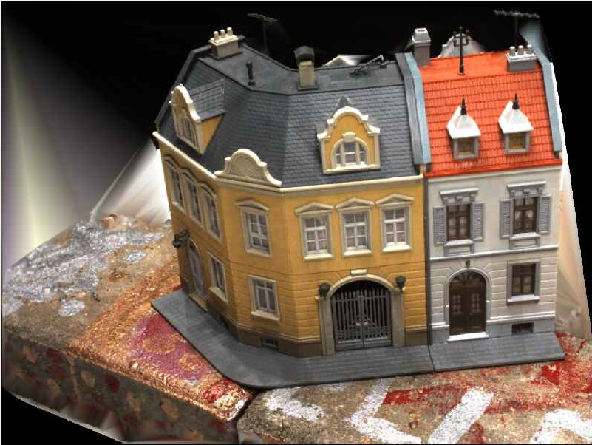

Figure 3: Enhanced Outcome Image from Image Plane of Camera 1

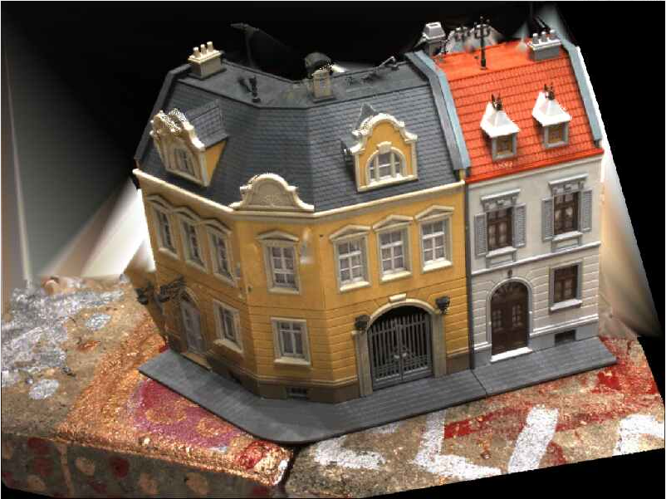

Figure 4: Enhanced Outcome Image from Image Plane of Camera 2

**Problem 2. Essential Matrix Constraint**

In this section of the experiment, the experimenters are asked to compute the SIFT feature of the given pair of images and used them as the correspondences for computing the essential matrices. One of the essential matrices are drawn out for drawing the epipolar line. The below shows the outcome:

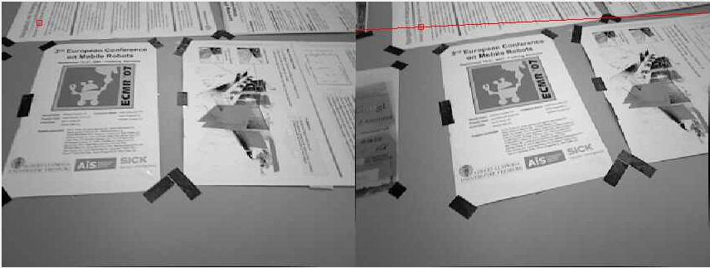

Figure 5: Epiploar Line (Red Line on Right) Result

**Problem 3. Answer the Following Questions**

**Question 1:**

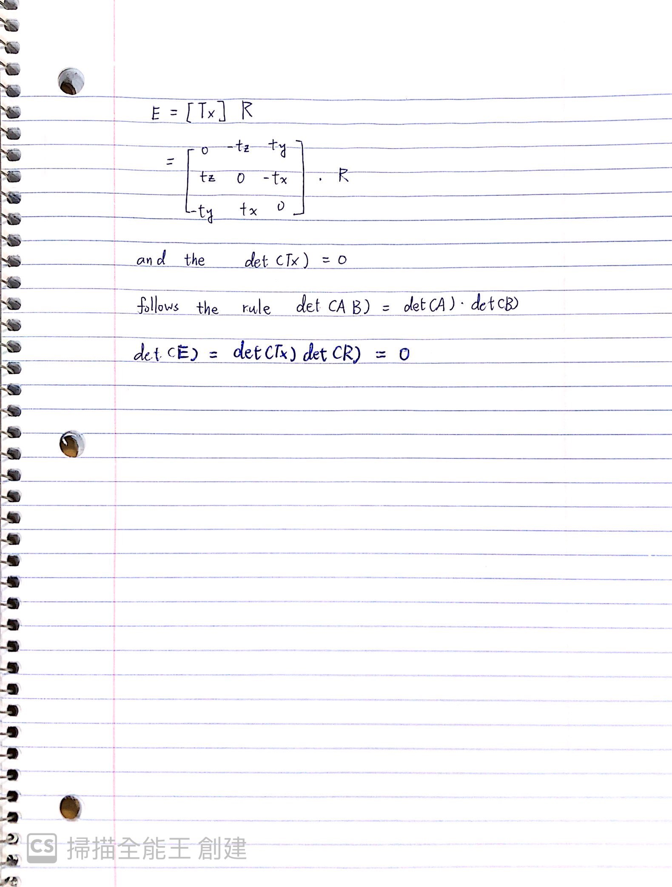

**Question 2:**

The two matches can be used to multiply with essential matrix. If the outcomes of the multiplication are 0 (or within a threshold), it can be considered as an inlier. Otherwise, it’s an outlier.